Case 2-ME-Akkad-Cylinder Seal-Carnelian-**Early Akkadian-**2400-2340 BCE

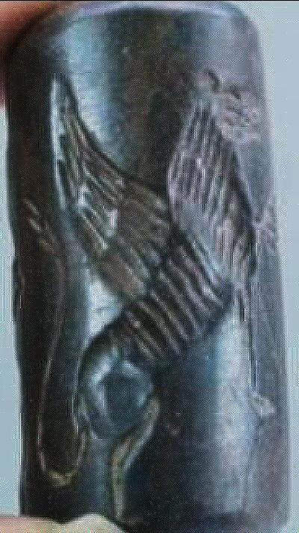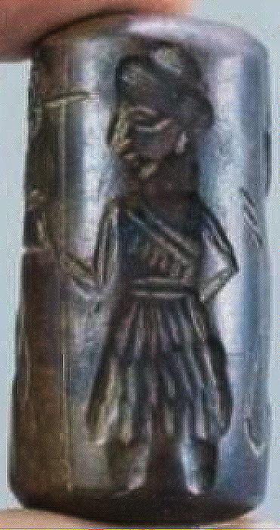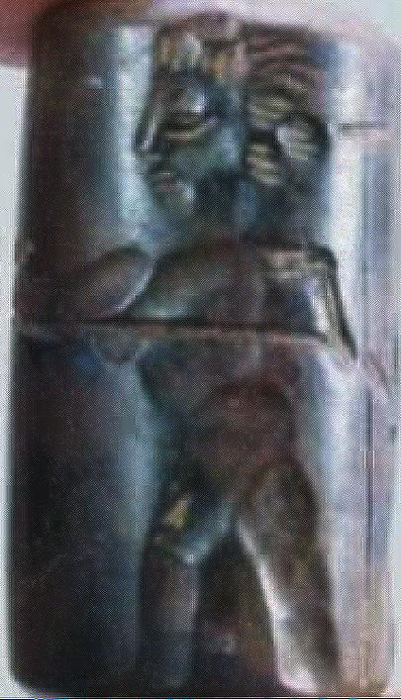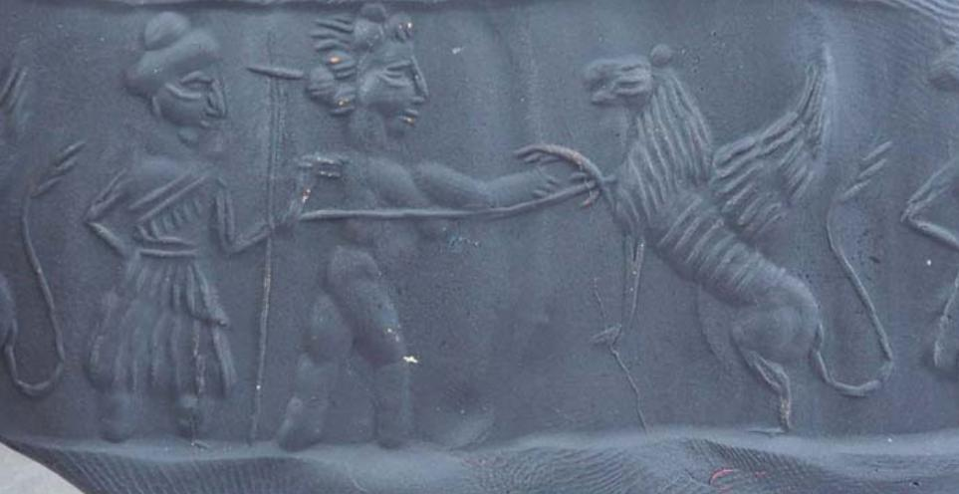

Akkad-Cylinder Seal-**Early Akkadian Period (ca.** 2400-2340 BCE**)**

**Formal Label:** Akkad-Cylinder Seal-**Early Akkadian Period (ca.** 2400-2340 BCE**)**

**Accession Number:**

Display Discussion:

**Early Akkadian Period (ca.** 2400-2340 BCE**) cylinder seal and roll-out scene of** Enshakushanna, first **king of Akkad (identified by his attendant holding his royal standard) about to dispatch a composite mythic raptor-beaked griffin and a winged Asian lion.**

This rare cylinder seal began an Akkadian-Assyrian tradition of ritualized royal hunting of the Asian-lion (*Panthera leo persica*) that became emblematic of Mesopotamian royal power and lasted some three-thousand years. This **Early Akkadian Period (ca.** 2400-2340 BCE**) cylinder seal, that depicts a king (identified by his royal standard being held by his attendant),** Enshakushanna, the first dynasty king of Akkad, the predecessor of Sargon I (ca 2340 – ca 2284 BCE), and the second dynasty king of Uruk (Van de Mieroop 1999: 74–75),. Enshakushanna, with a reign of 60 years (Jacobsen 1939), gathered all Akkadian and Sumerian speakers under one rule in Akkad and Uruk (2350 BCE- *ca* 2150 BCE) and conquered Hamazi, Kish and Nippur. By these conquests Enshakushanna claimed hegemony over Sumer, Uri-ki and Hamazi and adopted the Sumerian title *en ki-en-gi lugal kalam-ma* (Gantzert n.d.) which may be translated as "lord of Sumer and king of all the land" (or possibly as "*en* of the region of Uruk and *lugal* of the region of Ur"), and could correspond to the title *lugal ki-en-gi ki-uri* first “King of Sumer and Akkad” (Glassner 2000: 48).

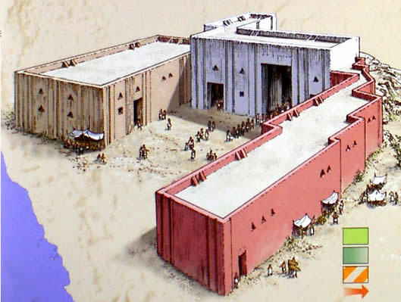

Reconstructed site of Akkad. After http://www.freeenglishsite.com/empires/empires/akkad/TepeGawra.jpg

**Date or Time Horizon:** **Early Akkadian Period (ca.** 2400-2340 BCE**)**

LC Number:

**Geographical Area:** southern Mesopotamia adjacent to Sumer

GPS:

Map:





Map of Enshakushanna’s Akkadian Empire ca 2340 BCE--Akkad and Uruk (Uri-ki) (2350 BCE- *ca* 2150 BCE), Hamazi, Kish and Nippur -- and the directions in which southern military campaigns were conducted (yellow arrows). Modfied after Map by CC BY-SA 3.0, 2010. https://upload.wikimedia.org/wikipedia/commons/thumb/3/37/Empire_akkad.svg/250px-Empire_akkad.svg.png

**Medium:** Carnelian, variety sard

**Dimensions:** L 3.4 cm

**Weight:**

**Condition: excellent**

**Provenance:**

Discussion:

This cylinder seal depiction of Enshakushanna anchors him in a three-thousand-year iconographic tradition linking him with the ritual killing of the Asian lion, the emblematic sign of Mesopotamian royal rule. **As the king offers his extended right hand to the Asian lion, he spears the lion with his concealed and unprotected left hand.** The depiction of the king’s right arm shows it to be much larger than his left arm. The general practice was to wrap some protective covering around the arm extended to the lion such as “a huge quantity of goats'-hair yarn or tent-cloth" (Reade 1998: 72-78). Henri Frankfort remarked that the use of this padding for defense, which was the accepted practice of engaging lions, was never depicted (Frankfort 1988), yet here it is. Simultaneously, as the king would extend one arm towards the beast, his other arm would firmly grasp a weapon, such as a spear (in this case) or a sword, by which he could quickly dispatch the animal with a single thrust.

Beginning in this **Early Akkadian Period (c** 2400-2340 BCE**),** symbolic killing of lions had been reserved for royalty, which again supports the contention that royalty commissioned this earliest cylinder seal. Later depictions of kings, were not nude but richly appareled, fighting lions and incorporated into an increasingly highly developed religio-politico public art. A religious dimension to this ritualized sacrifice is clearly shown in later bas-reliefs where the lion is shown in great agony indicating that the action was both necessary and demanded for atoning of the animal’s nature.

The lion may have become symbolic for the human enemy confronted in battle and its death may have been considered both horrific but necessary. This may be further supported by the fact that a surviving cuneiform indicates that when a lion was trapped in a provincial house, it must be delivered to the king. In fact, the number of lions killed in this royal ritual caused such an extensive depletion of the Asian lion that it is only found in a small population in India (Frankfort 1988: 187).

Sargon, the second ruler of the Semitic Akkadian Empire presided as king over Mesopotamia as a whole, ca 2340 – ca 2284 BCE (Glassner 2000: 48).

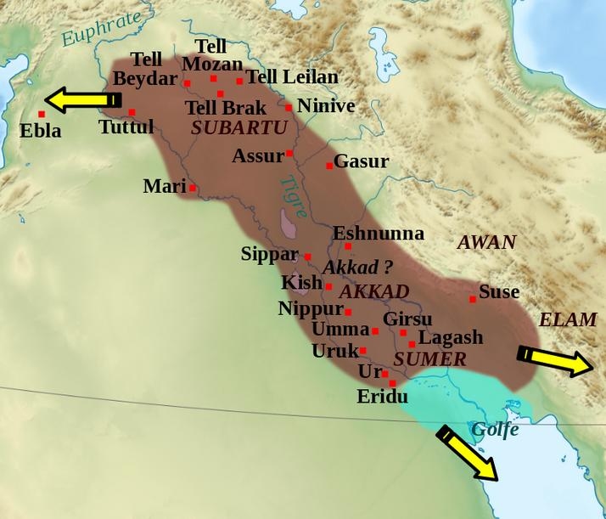

Map of the Akkadian empire during the reign of Sargon I (ca 2340 – ca 2284 BCE)

(short chronology). Map by CC BY-SA 3.0, 2010.

During Sargon I’s reign, conquests of other Sumerian city-states incurred such devastating results that his personage came to be regarded as embodying the attributes of both the wild Asian lion and the wild bull. This human-headed lion-bull figure or *lamassu* became emblematic of the king’s power over enemies and protection of his people.

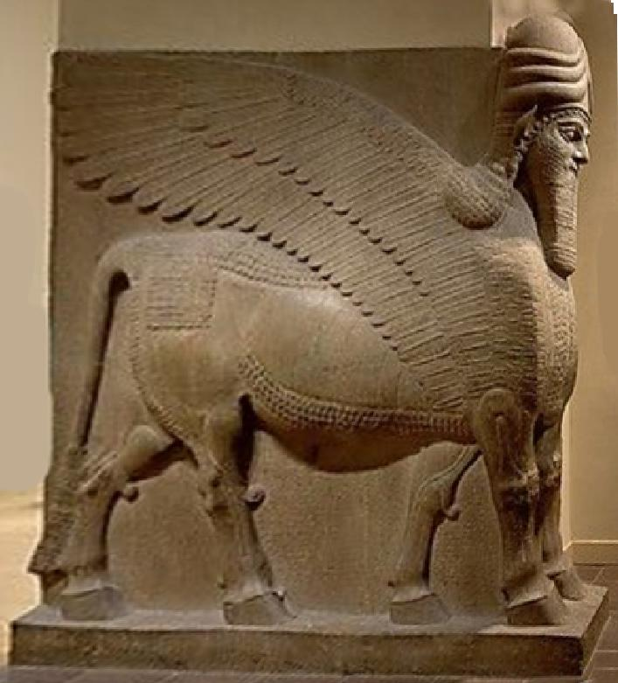

This figure is one of a pair of *lamassu* guardian figures from the palace of Ashurnasirpal II (883-859 BCE) at the Assyrian capital of Nimrud (ancient Kalhu). Photo of the statue at the Metropolitan Museum of Art, New York City.

*Lamassu* combined the strength of the bull, the swiftness of birds indicated by the wings, and the human intelligence crowned by three tiered bulls’ horns attesting to their divinity. They were designed to protect the palace from demonic forces and guarded the entrance to palace of the king. The figure has five legs, so that when viewed from the front it stands firm, while when viewed from the side it appears to be striding forward to combat evil. The belt signifies power. The standard inscription of Ashurnasirpal, common to many of these bas-reliefs, is inscribed between the figure's legs, recording the King's titles, ancestry and achievements.

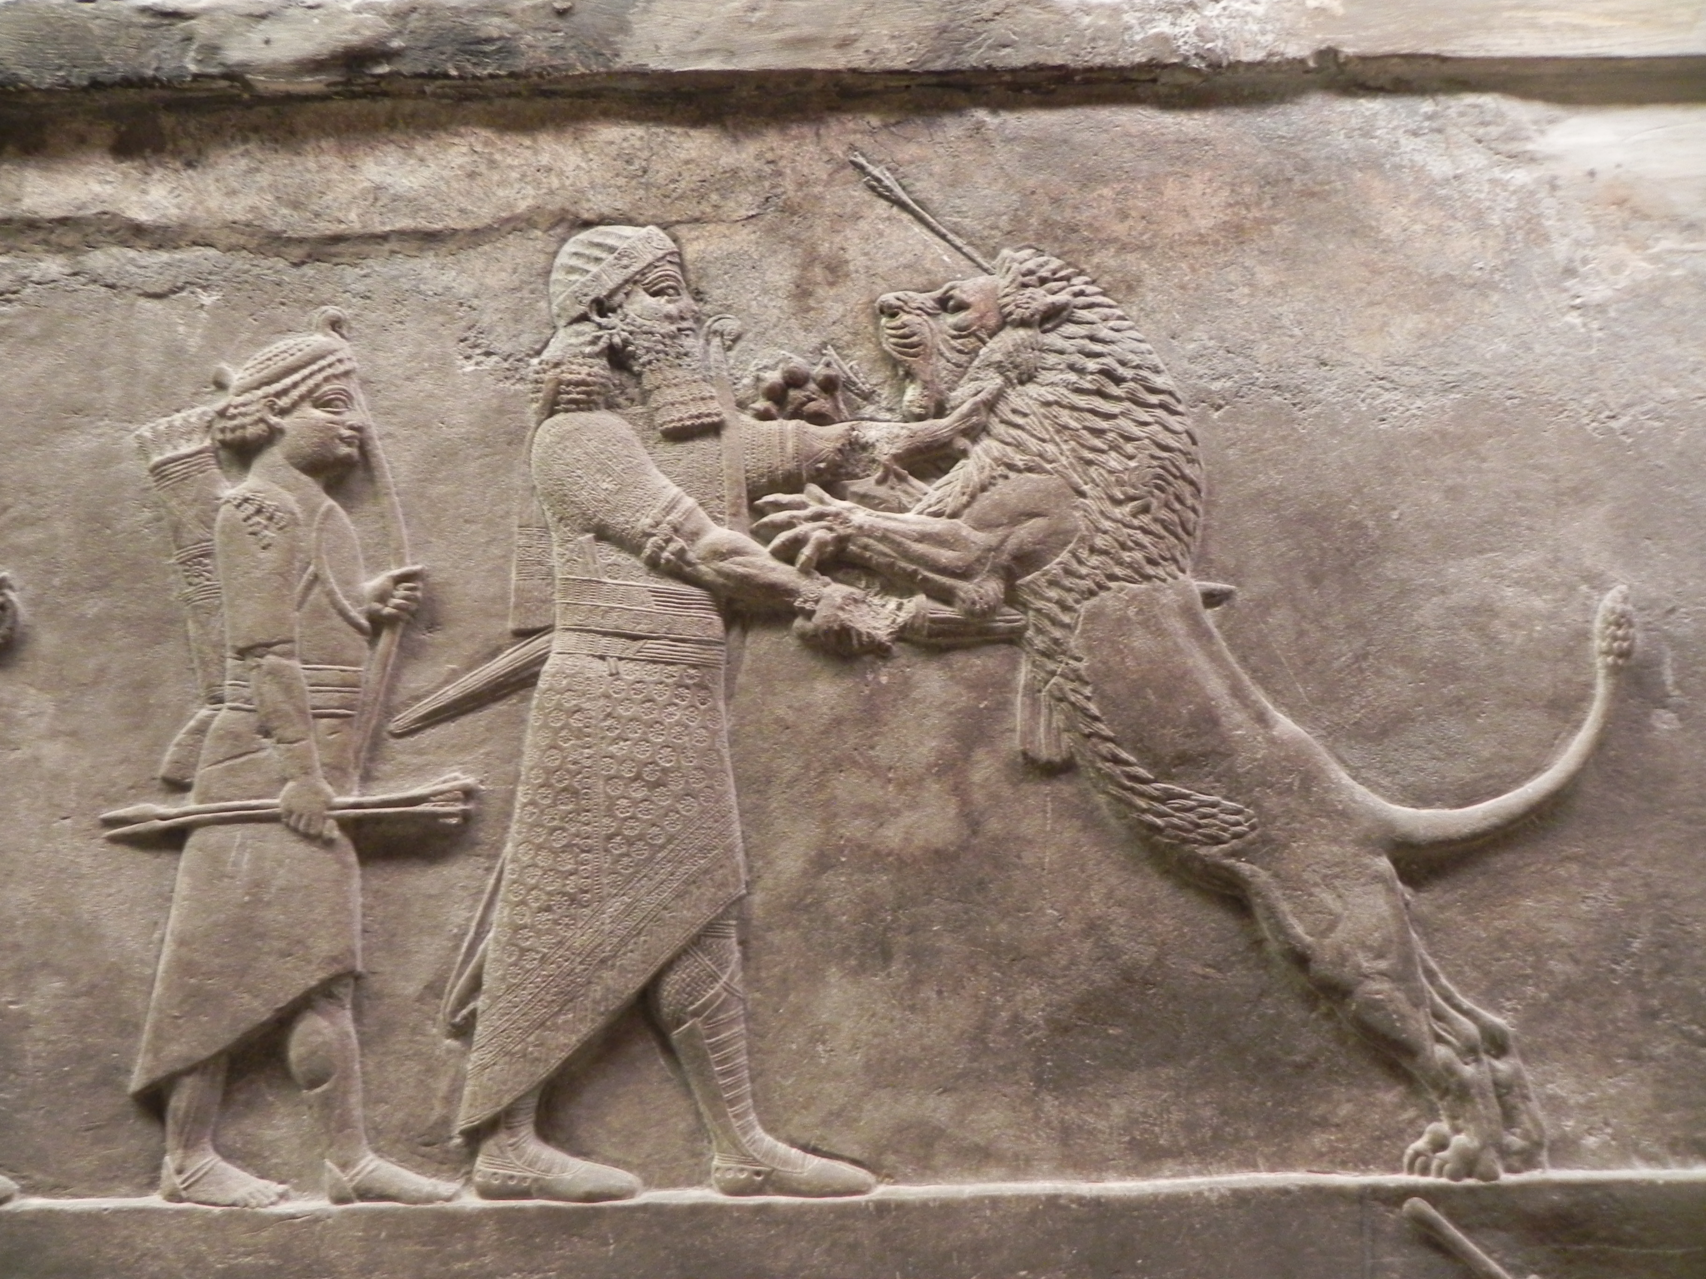

**Late Assyrian Period** bas-relief (645-635 BCE) of **Assurbanipal (**668– ca 627 BCE) **killing an Asian lion with a sword, after the king’s archer has wounded it in its forehead.** From the Royal Lion Hunt of Ashurbanipal reliefs from the North Palace of Nineveh that are now displayed in room 10a of the British Museum where this photo was taken. See Frankfort 1988: 188, Fig. 211.

**The visual effect of** the Royal Lion Hunt of Ashurbanipal **was probably intended to be an apotropaic warning to would-be enemies to be aware that Assyrian warriors were supremely capable and to be feared more than lions.** But it also had an ontological message: by displaying the king’s battle expertise and courage, Assyrians were superior warriors to their would-be enemies. This is the motif that had begun with the carnelian cylinder seal of Enshakushanna, the first **king of Akkad in the Early Akkadian Period (ca.** 2400-2340 BCE**).**

References:

Frankfort, Henri. 1988 [1970] *Art and Architecture of the Ancient Orient*. Penguin Books based on the 4th ed. London: Butler and Tanner co., Ltd.

Gantzert, M. n.d. The Emar Lexical Texts, Part 2 – Composite Edition. From https://openaccess.leidenuniv.nl/bitstream/handle/1887/17707/PDF%20-%20Part%202%20-%20Composite%20Edition.pdf?sequence=3.

Glassner, Jean-Jacques. 2000. Les pétits états Mésopotamiens à la fin du 4é et au cours du 3é millénaire. In: Hansen, Mogens Herman (ed.) *A Comparative Study of Thirty City-State Cultures*. Copenhagen: The Royal Danish Academy of Sciences and Letters.

Jacobsen, Thorkild. 1939. The Sumerian King List. Oriental Institute, Assyriological Studies 11, Chicago: University of Chicago Press.

Reade, Julian. 1998. *Assyrian Sculpture*. 2nd ed. London: The British Museum Press.

Van de Mieroop, Marc. 1999. *Cuneiform Texts and the Writing of History*, London: Routledge,